Name: Connor Williams Mark _____________________/50

[**Instructions**: Remove everything that is not a heading below and fill in with your own diagrams, etc.]

## Brief introduction __/3

I will be implementing collision detection system and taking advantage of Unity’s physics engine to enable real-world physics in our video game. The ship will be able to react to objects in the virtual world.

## Use case diagram with scenario __14

### Use Case Diagrams

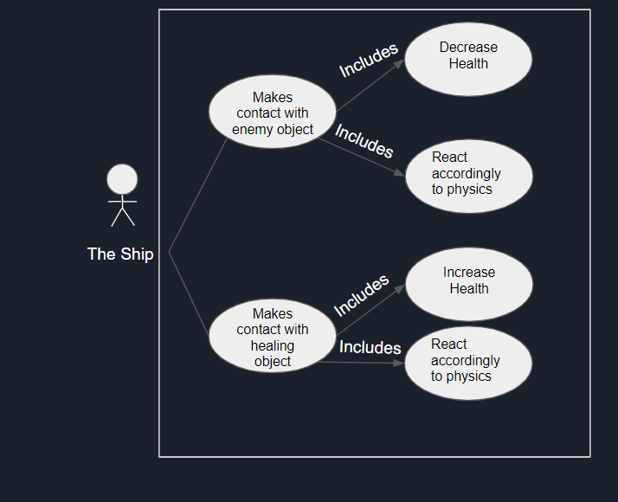

### Scenarios

**Name:** Contact enemy object

**Summary:** The ship contacts an enemy object.

**Actors:** The ship

**Preconditions:** Game has started.

**Basic sequence:**

**Step 1:** Ship hits object.

**Step 2:** Ship’s health is decreased.

**Step 3:** Ship reacts according to physics

**Exceptions:** None

**Post conditions:** Ships health decreases, and the ship will react to the collision.

**Priority:** 1*

**ID:** C01

*The priorities are 1 = must have, 2 = essential, 3 = nice to have.

**Name:** Contact healing object

**Summary:** The ship contacts a healing object.

**Actors:** The ship

**Preconditions:** Game has started.

**Basic sequence:**

**Step 1:** Ship hits object.

**Step 2:** Ship’s health is increased.

**Step 3:** Ship reacts according to physics

**Exceptions:** None

**Post conditions:** Ships health increases, and the ship will react to the collision.

**Priority:** 1*

**ID:** C01

*The priorities are 1 = must have, 2 = essential, 3 = nice to have.

## Data Flow diagram(s) from Level 0 to process description for your feature _______14

### Data Flow Diagrams



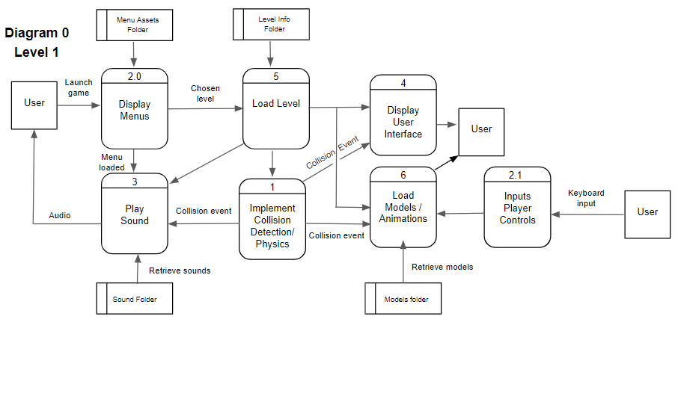



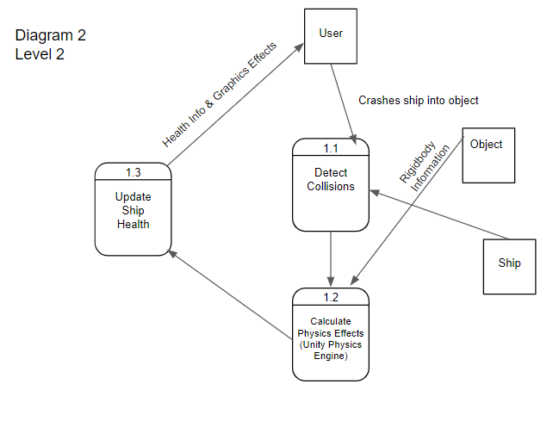

### Process Descriptions

Detect Collisions:

WHILE game is playing

IF collision detected

Send trigger to Unity Physics Engine

END IF

END WHILE

Calculate Physics Effects (Unity Physics Engine):

Receive object rigidbody information

Calculate graphics effects

Update screen

Trigger process 1.3 to update ship health

Update Ship Health:

IF collision was with enemy

Decrease ship health by n

END IF

IF collision was with health object

Increase ship health by n

END IF

## Acceptance Tests ________9

**Test ship health update system**

* Force ship to collide with an enemy
* Check if health was decreased
* Force ship to collide with a health object
* Check if health was increased

**Test Physics Usage**

* Observe ship as it moves through water
* Ensure it is moving properly
* Observe ship as it collides with game objects
* Ensure that ship is reacting properly

## Timeline _________/10

## Work items

|  |  |  |
| --- | --- | --- |
| Connor | Duration (Hrs.) | Predecessor Task(s) |
| 1. setup GIT Hub | 1 |  |
| 1. Create unity Project | 1 | 1 |
| 1. Ridgibody Creation | 10 | 2 |
| 1. Collision Detection | 12 | 3 |
| 1. testing | 10 | 3,4 |
| placeholder | 0 | 2 |

### Pert diagram

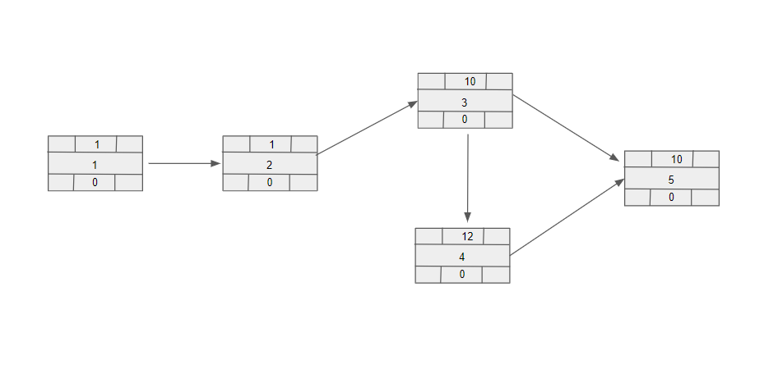

### Gantt timeline

